04-06-2026 Git hub : Ravi-kr987
Kowlas Ravi Teja
Documentation:
The Four T’s of risk treatment :
1. Treat ( Mitigate) : Reducing the risk to an acceptable level.
Ex : Installing a Web Application firewall ( WAF) to reduce the likelihood of SQL injection, combined with database encryption to reduce the impact of successful breach.
2. Transfer ( Share) : Transfering the risk to the third party by taking insurance.
3. Tolerate ( Accept) : Accepting the risk as it as without further treatment.
4. Terminate ( Avoid) : Terminating the risk means eliminating the activity, technology or process that creates the risk.
Control Frameworks overview: There are 4 types of frame works.
1. ISO 27001 Framework published by ISO/SEC and the control count 93 contols (22 edition) and best for certifications.
2. NIST 800-53 REV 5 Framework published by NIST and the control count 1000+ controls across 20 families and best for US federal agencies.
3. CIS V8 Framework published by Control for Internet Security and the control count is 18 total controls and 153 safeguards and best for organization seeking prioritized actionable guidance.
4. COBIT 2019 Framework published by ISACA and the control is 40 governance and management objectives and best for IT governance and enterprise alignment.
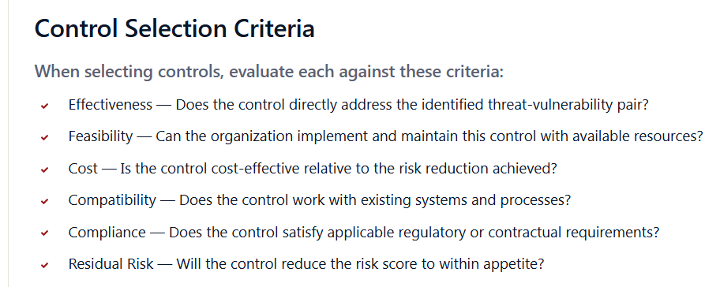
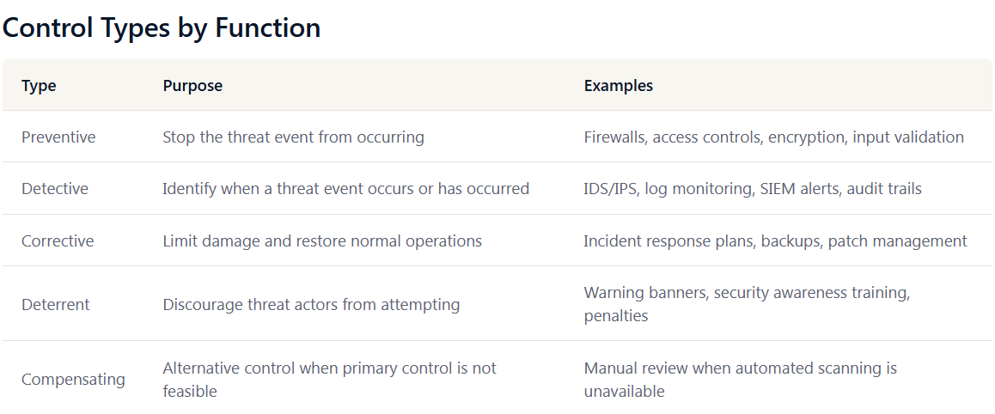
Why cost benefit analysis is important :
Security budget is finite and dollar amount spent on one control cannot be spent on other control. So Cost Benefit Analysis( CBA) ensures that treatment deliver maximum risk reduction spent on dollar amount. It is financial language that CFOs and board approves the security budget.
Return on Security Investment (ROSI) :
ROSI= (ALE before control- ALE after control)- Annual cost of control. If it is positive the control pays itself. If it is negative the control costs more than the risk mitigates.
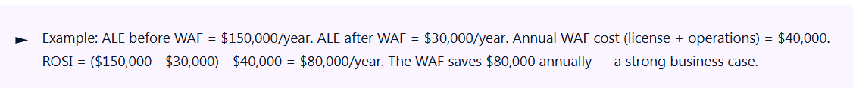

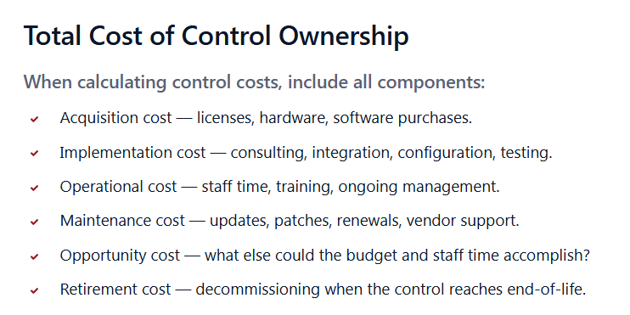
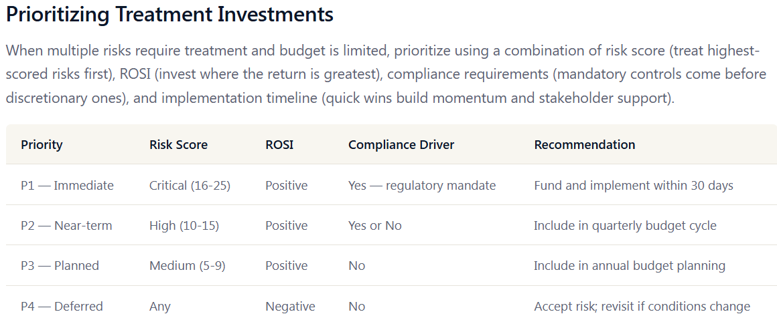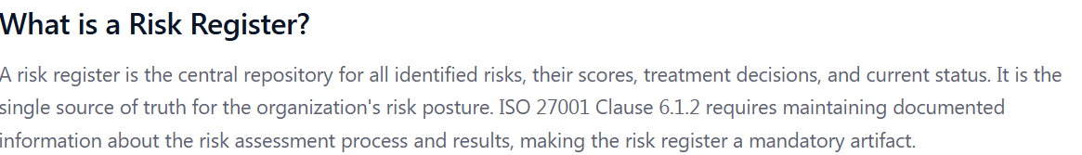
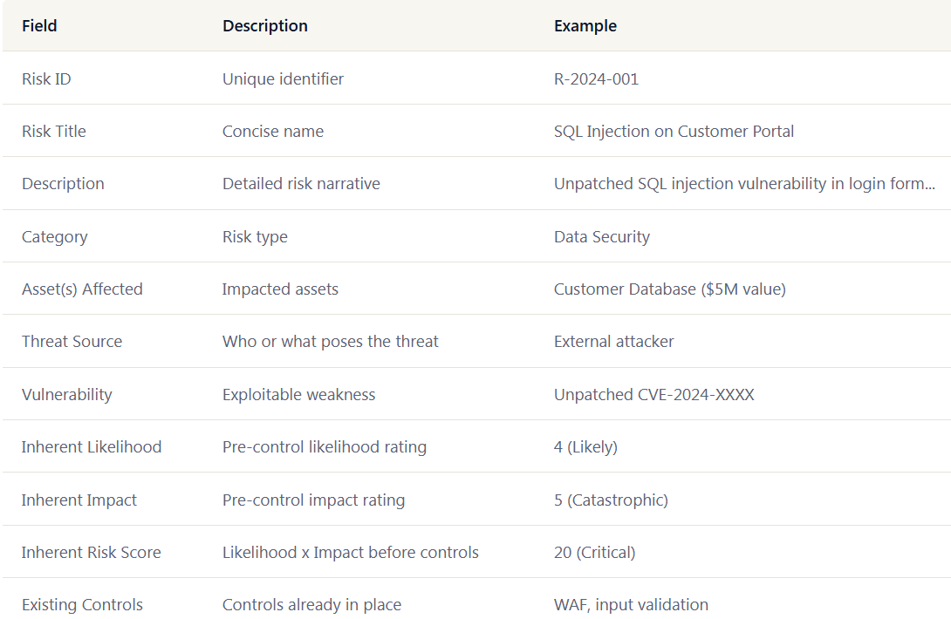
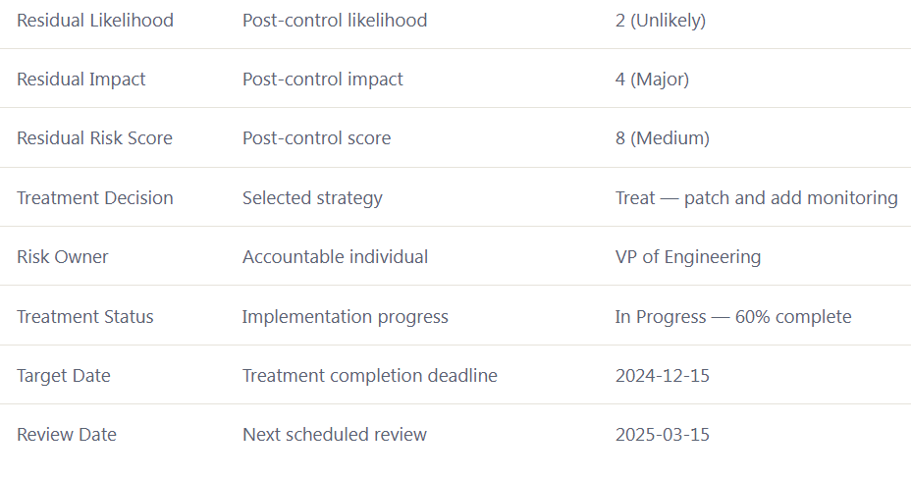

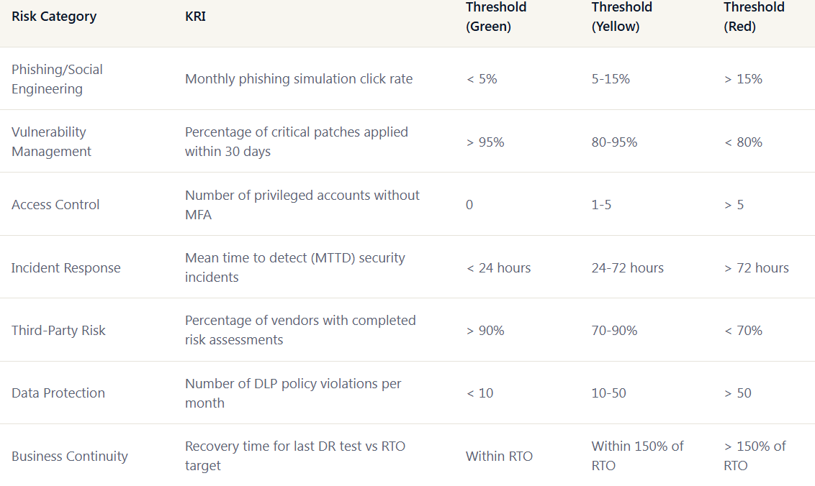 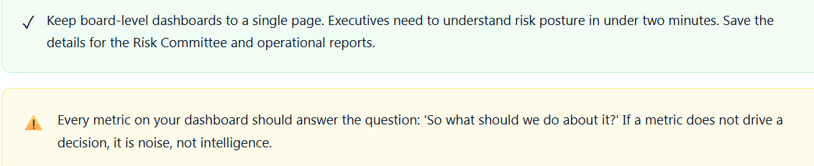
Today learnt Compare score with risk appetite and Risk Treatment and Document and Monitor topics. Earned Risk Assessment Certificate.
Also started GRC Enterprise Simulation and choosen domain IT/Saas Nexa Cloud Technologies and in training phases the phase 1 indicated business context completed the lessons and quiz and scenario.
09-06-2026:
Today learnt again security principles CIA Triad and Law and ISC2 code of ehics. Learnt Risk management and governance and laws.
Today started learning on nexa cloud phase 2 indicated security objectives and learned about ISO 27001 clause 6.2 information security objectives and how to implement it. Completed Quiz and scenario questions.
10-06-2026:
Today completed GRC simulation second scenario of Medisphere Global Hospitals in that Phase 1 Business context. Learned understanding Medisphere’s healthcare operations and Technology systems & Data sensitivity includes EHR ( Electronic Health Records), HIS ( Health Information System), LIS (Laboratory Information System) , PACS ( Picture Archiving and Communication System), Telemedicine platform and AI diagnostics engine and Hybrid Cloud Architecture and Data sensitivity and Hierarchy and AI integration in clinical decision – making.
Healthcare Regulatory Framework , Consent Management in Healthcare and Breach notiication Timelines and Obligations, Strategic Business Objectives.
Completed Quiz and scenario questions.
11-06-2026:
Today started learning about securiy objectives like if an hospital data is compromised it can lead to a patient death because emergency cannot access the patients electronic health records, clinicans must make life or death decisions without knowing the patients drug allergies ,blood type and conditions or current medications.
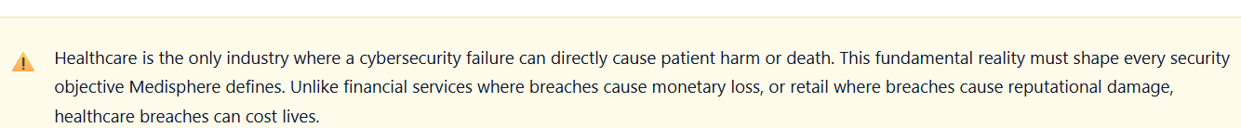
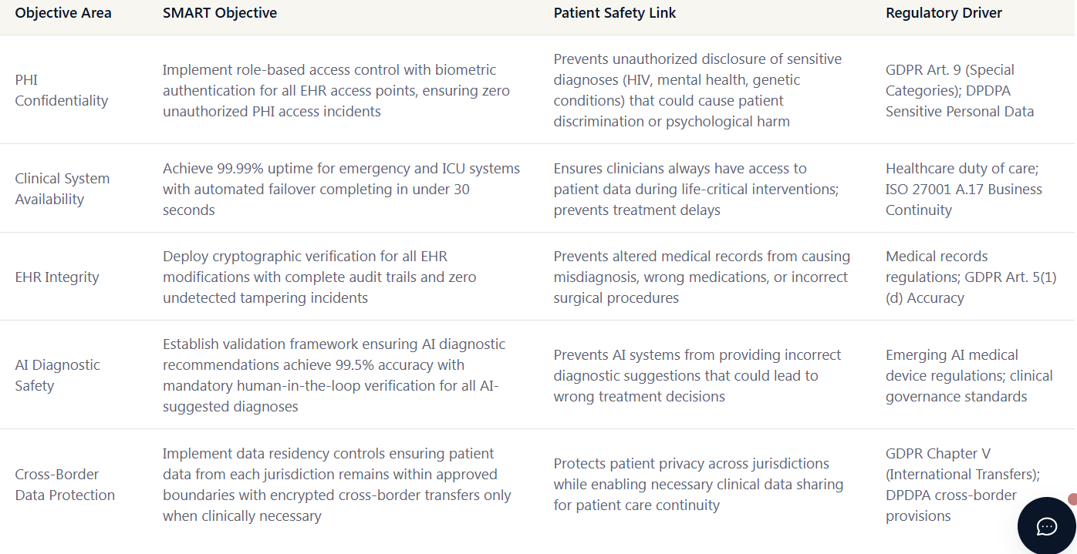

Next CIA triad in Clinical Environments:
In clinical environments, the CIA triad—Confidentiality, Integrity, and Availability—has a different priority order compared to most other industries. While financial services and SaaS platforms usually focus on confidentiality first, healthcare systems must prioritize availability above all. This is because if critical systems like ICU monitors, surgical navigation tools, or emergency department electronic health records (EHRs) go offline, patients’ lives could be at risk. Although confidentiality and integrity remain essential, they support the larger goal of ensuring safe and continuous patient care. Therefore, Medisphere must define its CIA-based security objectives with this clinical reality as the foundation.
Balancing Clinical Operations & Security :
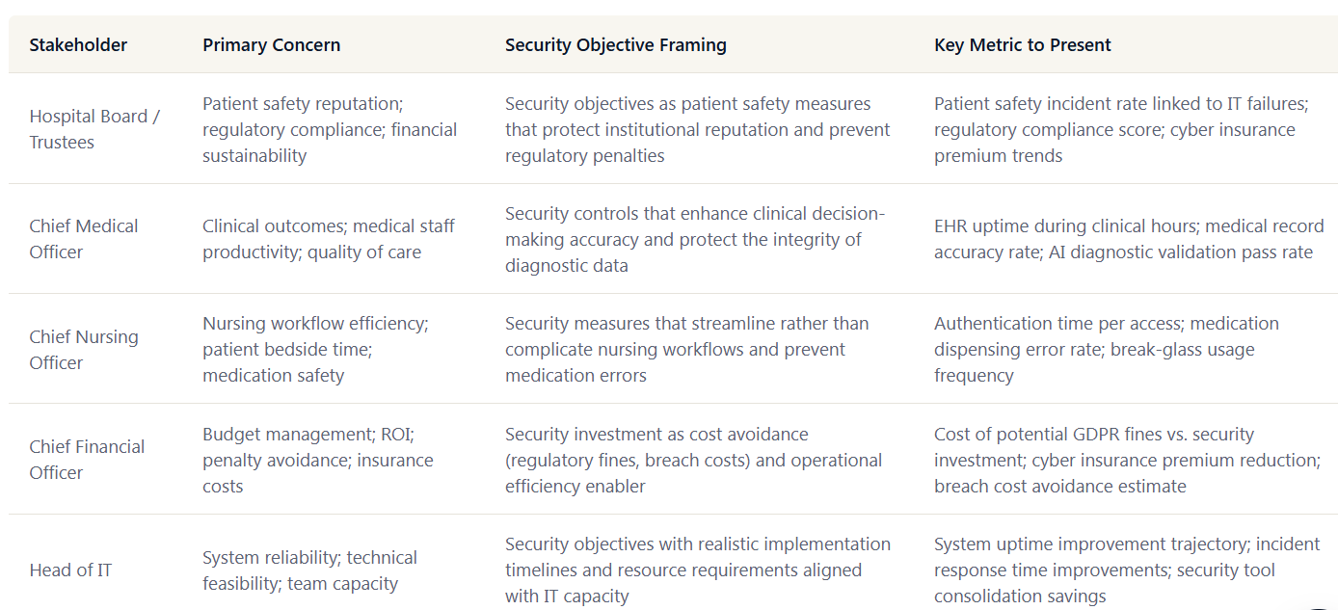
12-06-2026:
Today started learning another scenario Luxestay International – Business Context. First Understanding Luxestay’s Hospitality Business. Company was established in 2009 as a boutique hotel in Singapore and has expanded to one of Asia’s Europe most recognized luxury hospitality brands. The company operates 68 properties ranging from urban five star hotels to exclusive resort destinations employing approximately 12,000 staff across six countries.
It generates revenue through multiple interconnected channels each carrying distinct GRC implications. The core business revolves around room bookings through both direct channels (website, mobile app, phone reservations) and indirect channels (Online Travel agencies such as Booking.com, Expedia and Agoda). Beyond room revenue the company derives significant income from events, corporate travel contracts, loyalty program internships, and AI-driven upselling of premium services such as spa packages, dining experiences and guided excurcisons.
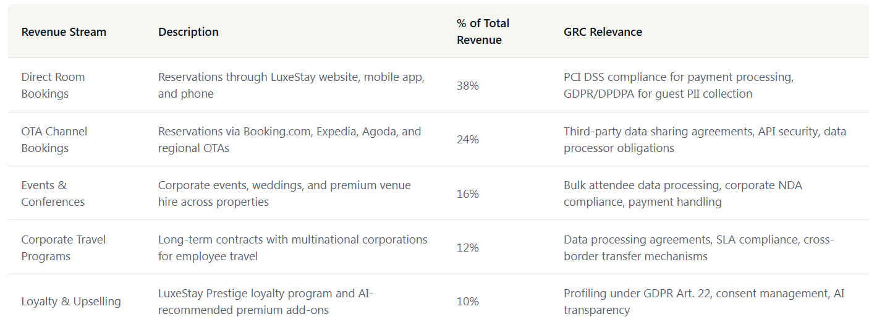
Key Points: OTA Ecosystem & Data Sharing Complexity
- Role of OTAs (Online Travel Agencies):
  - They act as major distribution channels for hotels like LuxeStay.
  - Also pose significant data security risks.
- Data Flow:
  - Guest data (name, contact info, travel dates, payment details) passes through OTA systems before reaching LuxeStay via API integrations.
- Data Relationship:
  - Creates a controller–processor relationship between OTA and LuxeStay.
  - Both must comply with GDPR and DPDPA regulations.
• Security Risks:
- API vulnerabilities or misconfigurations can expose guest data to unauthorized access.
• Data Retention & Jurisdiction Issues:
- OTAs may keep guest data for marketing purposes.
- A single booking can lead to personal data being processed in multiple countries under different legal frameworks.
Summary :
Emphasize that the OTA ecosystem involves complex data sharing, regulatory compliance, and security challenges — especially around API integration and multi-jurisdictional data processing.
- Multi- Location Operations & Guest Trust:
- India (22 properties): Subject to DPDPA 2023 for domestic guess data , RBI Guidelines.
- Singapore(8 properties) : Subject to PDPA Singapore, MAS technology risk management guidelines and cross border requirements.
- Thailand (12 properties) : Subject to PDPA Thailand, BOI regulations for foreign investment, and local hospitality licensing requirements that mandate certain data retention periods.
- France ( 10 properties) : Subject to GDPR with CNIL as the supervisory authority,French labor code for employee monitoring and tourism industry specific regulations.
- Germany ( 9 properties) : Subject to GDPR with strict interpretation by German DPAs, Federal Data Protection Act ( BDSG) supplements, and works council requirements for employee data.
- Italy (7 properties) : Subject to GDPR with Garante as the supervisory authority, specific Italian rules on cookie consent and video surveillance in hotel premises.
Technology Architecture and Payment Ecosystem :
Core Technology Systems:
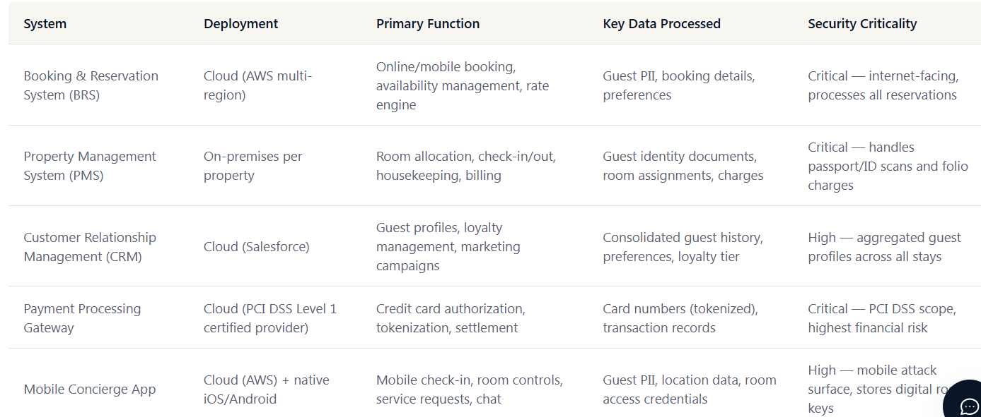
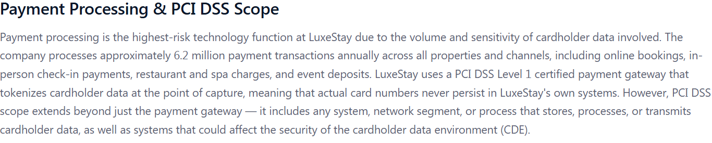
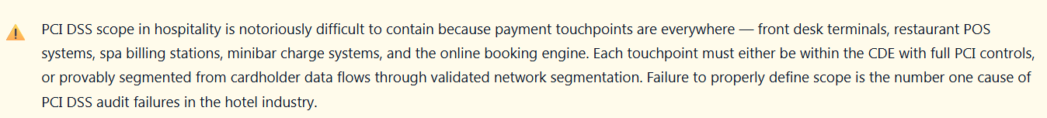
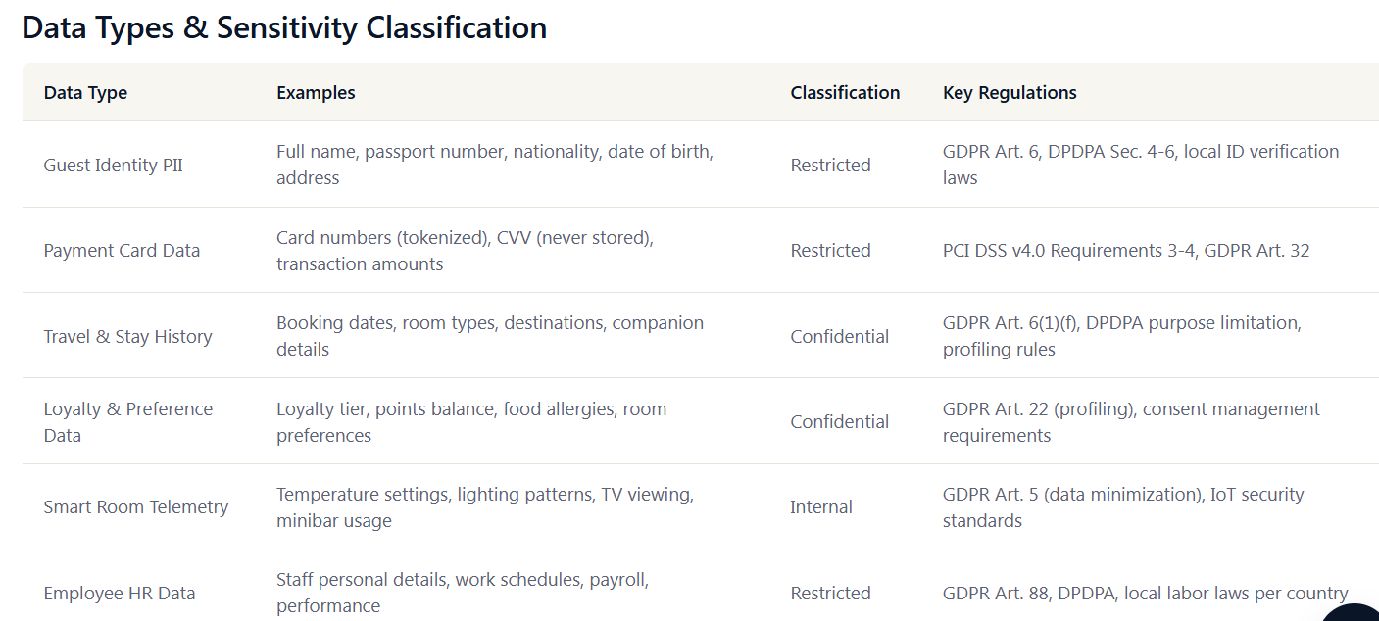
13-06-2026: Luxe stay International- Business Objectives
Today started learning about Compliance Landscape & Business Objectives. First PCI DSS Compliance for payment security. PCI DSS (Payment Card Industry Data Security Standard) is the non negotiable compliance requirement for Luxestay given its massive payment processing volume. For Luxestay, the challenge lies in applying PCI controls consistently across 68 properties each with its own POS terminals, network infrastructure and staff.
PCI DSS non compliance consequences extend far beyond fines. Card brands ( Visa, Mastercard) can increase transaction fees, impose restrictions, or ultimately revoke Luxestay’s ability to process card payments entirely. For a luxury hotel chain where virtually 100% of transactions are card-based, losing card processing capability would be an existential business threat.
GDPR Compliance Across European Countries: The General Data Protection Regulation (GDPR) governs how Luxestay collects,process, stores and tranfers personal data of guests, employees, and business contacts within its European operation in France, Germany and Italy. Luxestay acts as a data controller for guest data collected through its own booking channels and as a joint controller or processor depending on the arrangement with OTAs.
DPDPA Compliance for Indian Operations: India’s Digital Protection Data Protection Act (DPDPA) 2023 applies to all 22 Luxestay properties in India and to any processing of Indian guests data regardless of where the processing occurs. The DPDPA requires Luxestay to obtain valid consent before processing personal data, provide clear notice of the purpose and scope of data collection including the right to correction, erasure and grievance redressal. The Data Protection Board of India can impose penalties of up to 250 crore (approximately USD 30 million) for significant non compliance, making DPDPA enforcement a material financial risk for the company.
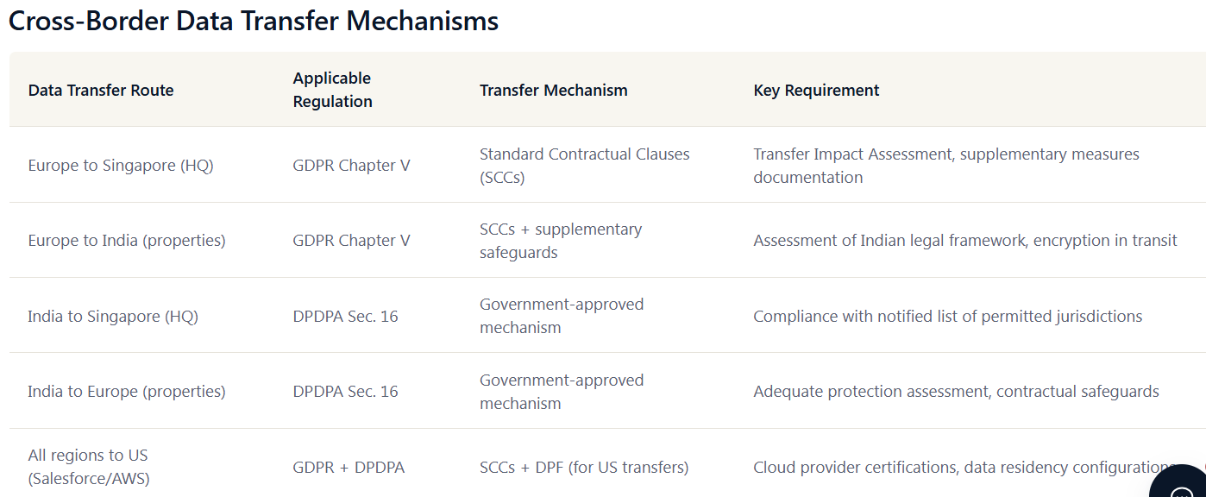
Breach Notification Obligations :
Under GDPR data breach must be reported withing 72 hours of becoming aware of the breach and affected individuals must be notified without undue delay of if the breach poses a high risk to their rights and freedoms. Under DPDPA breaches must be reported to the Data Protection Board of India and affected data principles as prescribed by regulations. PCI DSS requires immediate notification to the acquiring bank and card brands if cardholder data is compromised followed by a forensic investigation by a PCI forensic Investigator (PFI). The overlapping timelines mean that a single breach involving European guest payment data processed through an Indian property could trigger simultaneous notification obligation to CNIL, the Data Protection Board of India, Visa/Mastercard, and the acquiring bank all within 72 hours.
Business Objective & GRC Alignment:
- If the main site goes down, traffic will automatically switch to the redundant site.
- This ensures continuous availability for users without interruption.
- The failover process is automatic, requiring no manual action.
- Helps maintain business continuity and customer trust.
- Reduces risk of downtime losses and service disruption.
Completed quiz and scenario based questions.

16-06-2026: Luxe stay International – Security Objectives :
Security Objectives for Hospitality:
The hospitality industry sits at a unique intersection of high-volume payment processing, sensitive guest personal data, and the expectation of seamless 24/7 service. For a luxury hotel chain like LuxeStay International, a security breach does not just trigger regulatory fines — it shatters the trust that guests place in the brand when they hand over passports, credit cards, and personal preferences. Security objectives in this environment must therefore serve dual masters: regulatory compliance and brand reputation.
ISO 27001 Clause 6.2 for Hotels:
ISO 27001 clause 6.2 requires organizations to establish information security objectives at relevant functions and levels. For a hotel chain, this means objectives must cascade from the corporate CISO all the way down to the night audit team at each property. Each objective must be measurable, monitored, communicated to relevant personnel, and updated as conditions change. The standard also requires that objectives be consistent with the information security policy and take into account applicable security requirements and risk assessment results.
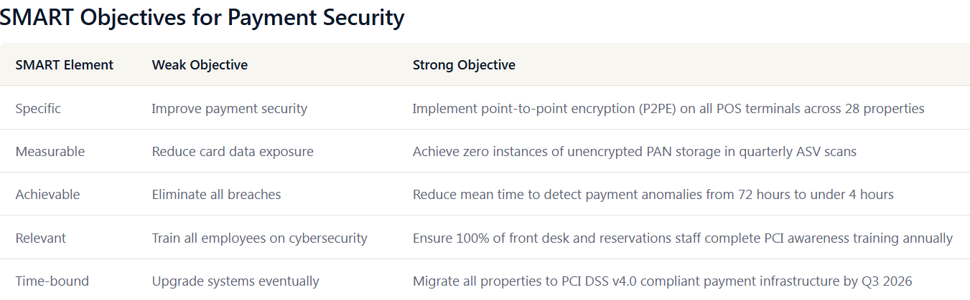
CIA Triad in Payment and Guest Data :
Applying CIA triad to a luxury hotel chain requires understanding that different data assets have dramatically different priority weightings. Cardholder data demands the highest confidentiality controls, reservation records require absolute integrity to prevent billing disputes and booking systems demand near perfect availability during peak travel sessions. Getting this balance wrong- for example, implementing overly aggressive access controls that lock front desk staff out during check in rush – can be as damaging as a data breach.
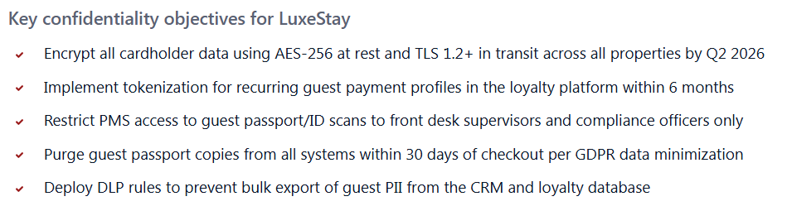
Integrity: Ensuring Accurate Reservations and Billing:
A corrupted reservation record can result in double bookings, incorrect billing, or a VIP guest arriving to find their suite unavailable. In a luxury context such errors are catastrophic to the brand. Integrity objectives must address the accuracy of data flowing between the booking engine, OTA channels (Booking.com, Expedia), the PMS and the billing system. SCADA- like precision is needed for rate integrity- if a dynamic pricing algorithm is tampered with, rooms could be sold at a fraction of their value, causing massive revenue loss.
Availability: The Booking Engine Never Sleeps:
Unlike many industries where brief downtime is tolerable, hotel bookings systems must operate continuously across global time zones. A guest in Tokyo booking a Paris property at 2 AM local time expects instant information. PCI DSS requirement 10 and ISO 27001 Annex A controls around operational security both support the availability dimension. Luxestay must define recovery time objectives (RTO) and recovery point objectives(RPO) for each critical system, with the booking engine and payment gateway receiving the most aggressive targets.
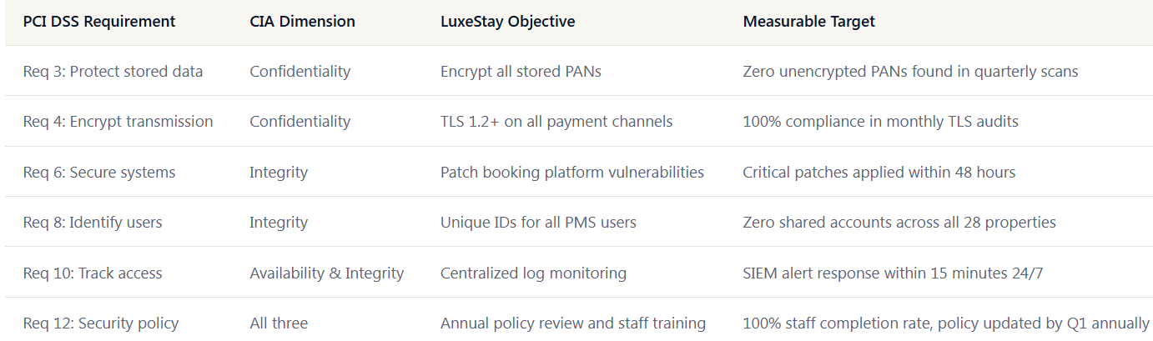
Multi- Stakeholder Objective Setting :
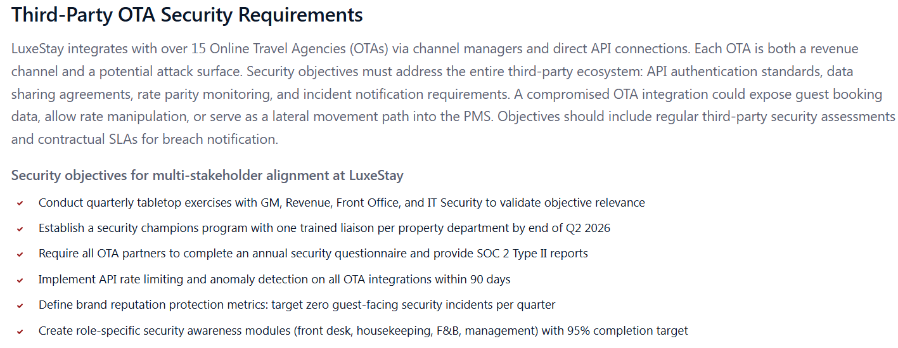
Completed quiz and scenario questions and answers.

